A week of WELLBEING at work

Monday

Tuesday

Wednesday

Thursday

Friday

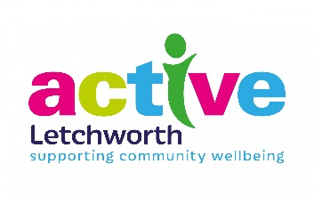

Being active during the working week increases your energy, helps to maintain a healthy weight, reduces stress, improves sleep and boosts creativity.
What will you do this week?

